**Automatic focus and focus measuring requirements:**

* There will be a new tab added to the center Tab Control pane
* Focus measuring and automatic finding of the best focus will be initiated manually by the user (never automatically)
* There needs to be a button to apply a circular ROI around a band. The program will use circle detection to find the center of the target. The user will be given a cursor that can be placed ON the band they wish to focus around. The ROI will be done by placing a mask outside a circle XX pixels bigger than the circle created with the center point and the cursor placed by the user and another mask will be applied inside a circle XX pixels smaller.
* The pop-out window will be used to place the ROI
* There needs to be a button on the GUI to measure the current focus. If the circular ROI is placed around a band, it should instead find the focus for that ROI.
* There needs to be a button to automatically find the best focus. If the circular ROI is placed around a band, it should be the best focus around that ROI.
* There needs to be a button to remove the circular ROI.

**Notes:**

There is a function in EMGU to measure histogram entropy (for focus measurement). Dean is looking into this function to determine if this is what we need for measuring the focus.

Best focus can be found by measuring the focus as the Navitar motor moves to find the best one. Look up an algorithm for finding the best focus to ensure there is no issue with an infinite loop of back-and-forth motor changes.

Circular ROI could be used to apply a mask inside and out to measure the focus of a specific band.

Annular ROI – segments B-band from full target image and creates a mask

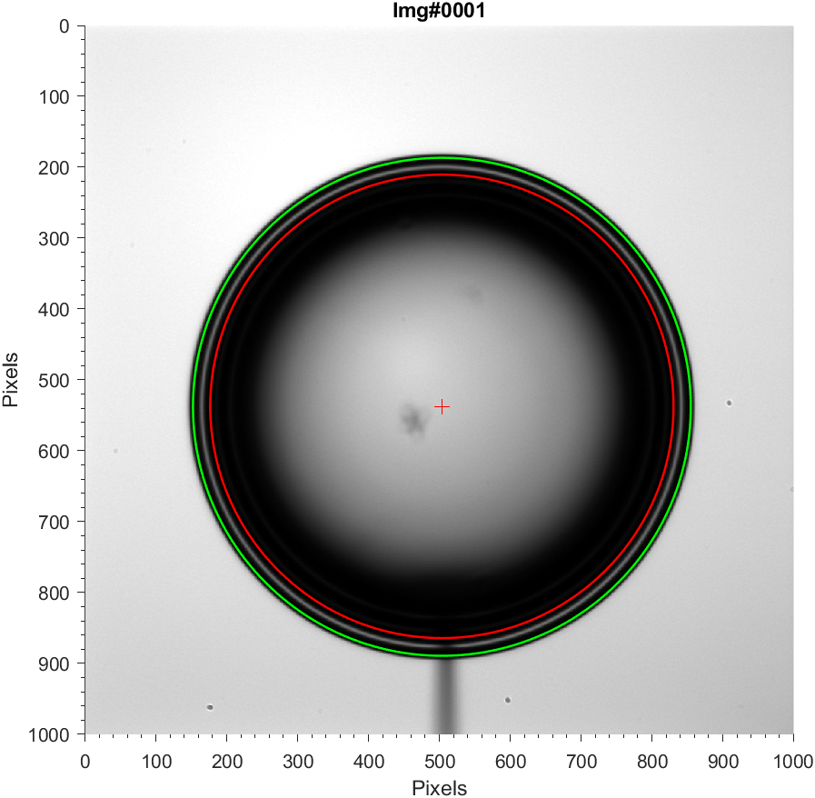=

Applying the mask “cuts out” the band we want to focus on. Histogram Entropy (HISE) algorithm then returns a single metric that can be used as focus measure.

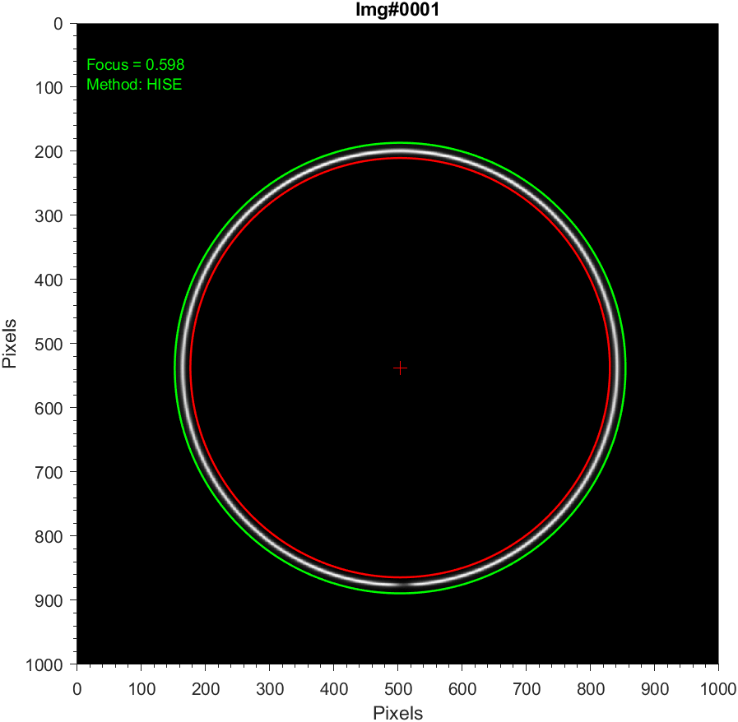

Same concept can be used to disregard B-band and focus on U-band

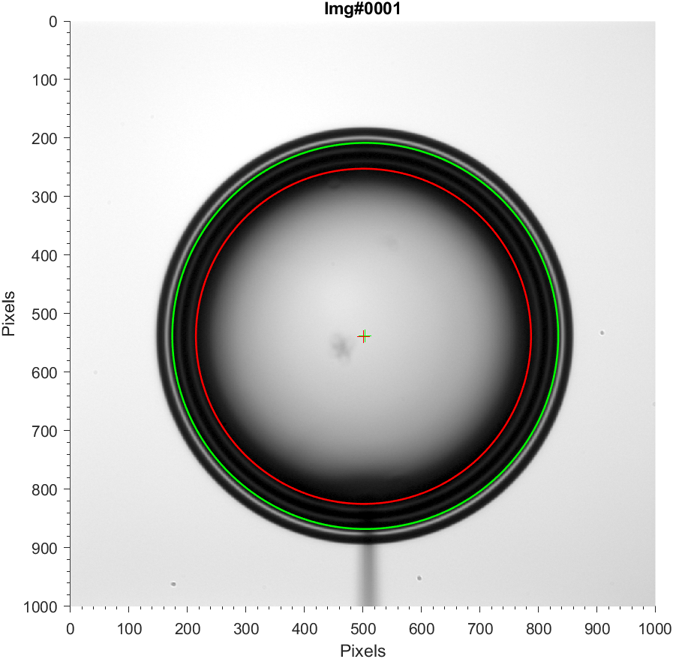

U-band contrast can then be optimized and HISE algo run to get focus metric

